TATTOO AFTERCARE
STEP 1: Second Skin
Right now you should have Second Skin placed on your tattoo and have just left your tattoo appointment.
You will be keeping this piece of Second Skin on for the first 24hrs of having your tattoo.
During this time it will fill with a lot of plasma and liquid that can look coloured, but it is not the ink falling out. It should look really gross, so don’t worry this is normal.

However during these 24hrs, if the skin around the tattoo (where the adhesive is stuck) becomes red/inflamed/itchy, this is not normal and can be a reaction to the adhesive. At any signs of this, please take the second skin off. Also if the Second skin starts to fall off exposing the tattoo, just take it off, don’t try to re-stick it in case any bacteria has gotten underneath.
If the Second Skin falls off before the first night of having the tattoo, please remove and give the tattoo a really good wash, and wrap the tattoo in Glad Wrap while you sleep. No cream or anything under the Glad Wrap. The tattoo will need to weep as much as possible in the first 24hrs to avoid thick chunky scabs when healing.

At the 24hr mark, to remove the Second Skin please do so in the shower. Peel it away very slowly under the running water. Once removed, give the tattoo a very very good wash with water and soap (preferably antibacterial soap, but anything natural without fragrances works great too).
Please make sure it is washed well and all the plasma that weeped out while in the Second Skin is washed off.
After the shower just let the tattoo air dry (no rubbing or patting with towels). Then apply a thin and small layer of Aftercare tattoo balm (of your choice).

STEP 2: Wound(tattoo) is healing and closing
Repeat this for 14 days. It takes 14 days for the wound to close, NOT TO FULLY HEAL. So each day apply a thin layer of cream morning and night, making sure the tattoo is clean first. Please only small amounts of balm. More is not better in this case, too much balm wont allow the wound to breath and start forming new skin.
Over creaming can prolong the wound closing.
Same reason no swimming or baths are allowed during these 2 weeks, we don’t want the wound to soak and stay open.
During the day, if the tattoo feels too dry and the skin might crack, then you can apply another thin layer. If the healing skin breaks this can cause scars. So try to avoid excessive movement like exercising.
Also why we say to please not itch or pick at the healing skin, it will fall off when its ready. No matter how thick the scabs are or itchy it gets. Again, it can cause scars if you pick the skin off when it is not ready to come off.
Direct sunlight for prolonged periods of time can also affect the healing. So please try to keep the tattoo out of the sun while you have delicate healing skin. The sun can burn the new skin and damage the new skin, also causing scars.

STEP 3: Protecting the tattoo while it settles into the skin
After the 2 weeks, the wound should be closed, but it can take another 2 weeks for the tattoo to fully settle into the skin. There can be another layer of skin that will flake away, it depends on how big the wound/tattoo is. So during these next 2 weeks please keep applying the balm morning and night, and be careful with the skin thats falling off.
But as the wound is closed, you can now start applying sun cream to protect it when going outside, go swimming for short periods of time and resume usual exercise. All with caution. Especially for colour tattoos, as colour can fade in the sun, protecting it when outside is the most important. For your tattoo and colour to stay crisp and fresh for the longest, alway apply sun cream and moisturise your skin.

After 4 weeks of healing we will know how it has healed and if it needs a touch up. The first touch ups are always free as it will correct anything that happened during healing. Any touch ups after that to re-fresh the tattoo will be charged.

Colour healing can be a lot more intense than most black&grey tattoos as it opens more skin. For this reason i have attached photos on the back of what usual colour healing looks like. Please have a look as I’ve had many people freak out and worry about the healing when its actually going really well.
However, if you think at all that the tattoo may be infected i please ask that you contact me first before a doctor. Again I’ve had doctors give clients antibiotics when the tattoo was never infected. Please send me lots of close up clear images of the areas of concern and i will let you know what my professional opinion is (we are all trained in infection prevention and what to do if there is an infection). I always keep an eye out for these emails and will reply asap. There is a lot of misinformation on social media so please ask tattoo professionals first.
Signs of infection include; intense redness, very hot wound, yellow puss, bubbles of puss forming.

Tips for Aftercare cream:
- Keep in fridge, it can not be stored anywhere above 21C usually (see package for your brand)
- Always wash hands before dipping in with your fingers.
- Don't let any other person use it due to cross contamination

Example pictures: (in these pictures you'll see me healing a tattoo on my own body)

Day 2 of healing, after the second skin is off and the tattoo is washed. Showing how much balm i use.
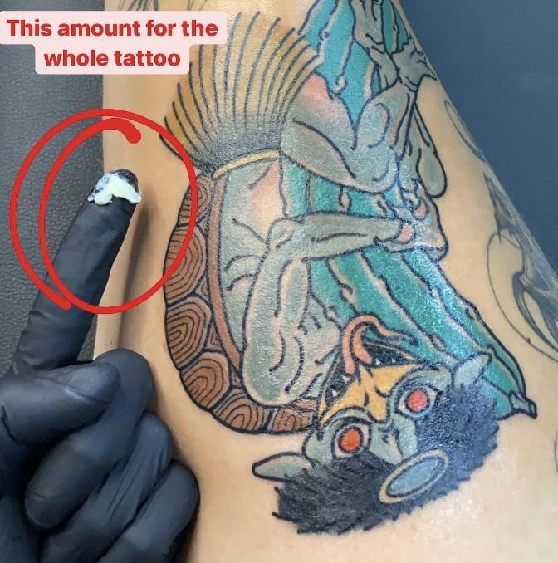
Day 5 of healing, the scabs/flaky skin has formed 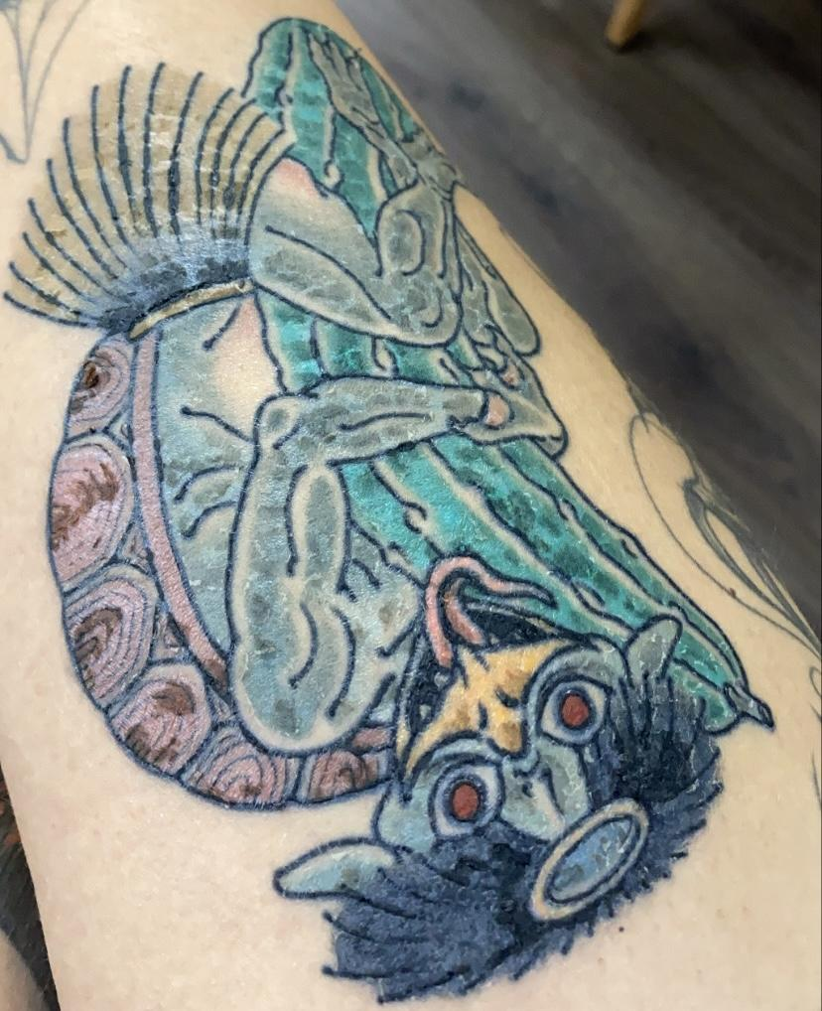
Day 11 of healing, chunky scabs are gone but still areas of skin that will peel off
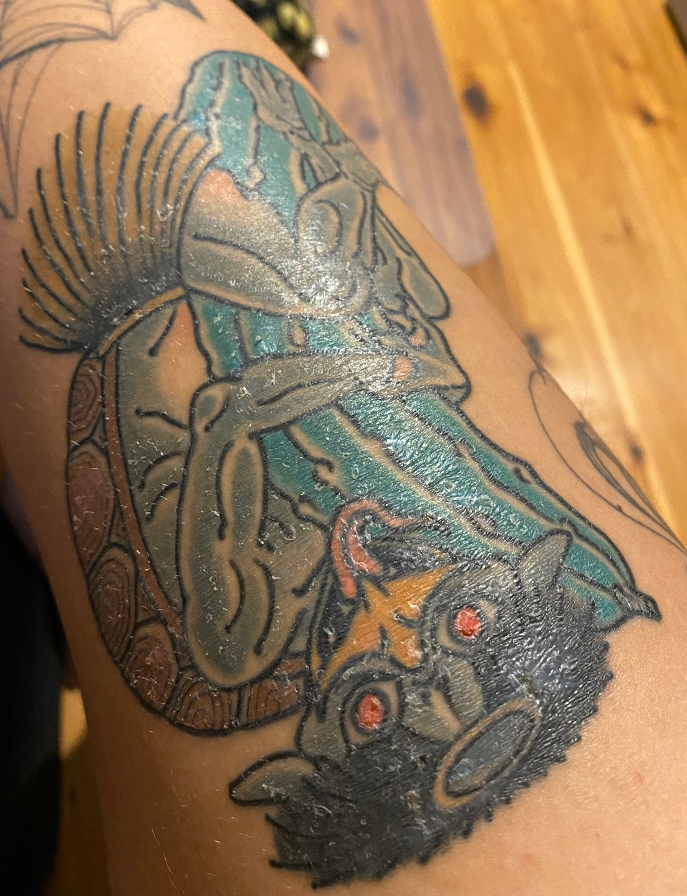Day 14 of healing (2 weeks), wound is now closed but there’s still skin to fall off over the next 2 weeks (as circled)
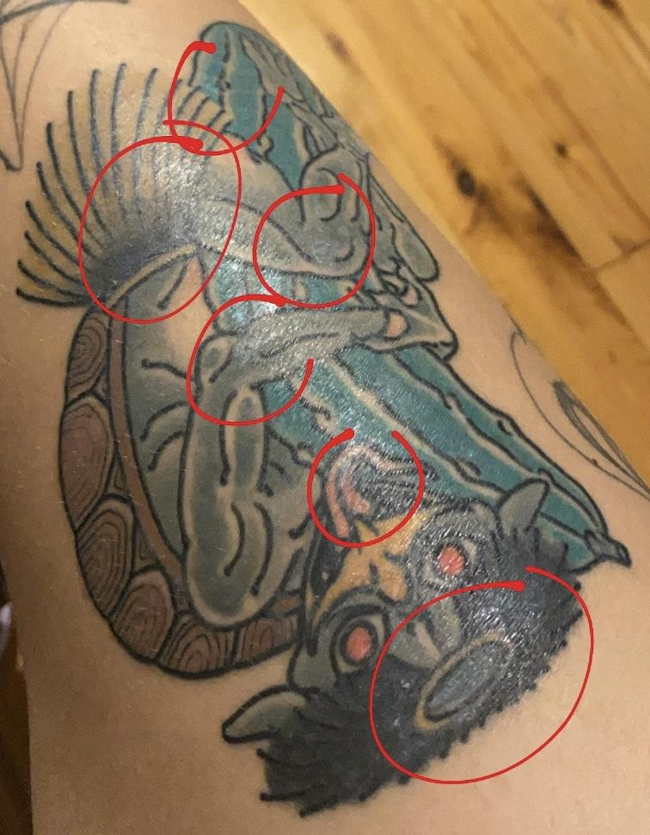
Day 28 of healing (1 month), everything is settled and there’s no more healing skin, hair growing back


